Name: Probin T Bhagchandani
ID: 22DCE006
Department: DEPSTAR Computer Engineering(CE-1)
Semester: III
Subject: IT283-WebDesigning & UI/UX
Assignment: HTML Assignment-1

1)Student Registration Form
Source Code:
<!DOCTYPE html>
<html>
<head>
<title>Student Registration Form</title>
<style>
body {
background-color: #000;
color: white;
font-size: large;
margin: 0;
}
h1 {
text-align: center;
color:cyan;
font-size: 55px;
}
label {
font-size:xx-large;
display: block;
margin-bottom: 10px;
}
input {
font-size: large;
width: 100%;
padding: 10px;
border: 2px solid white;
border-radius: 10px;
}
input[type="submit"] {
background-color:crimson;
align-self:center;
width:100%;
font-size: x-large;
font-weight:bold;
color:wheat;
cursor: pointer;
}
a {
text-align: center;
font-size: large;
color:white;
text-decoration:none;
}
</style>
</head>
<body>
<h1>Student Registration Form</h1>
<form method="post">
<label for="first_name">First Name:</label>
<input type="text" id="first_name" name="first_name"><br>
<br><label for="last_name">Last Name:</label>
<input type="text" id="last_name" name="last_name"><br>
<br><label for="contact_number">Contact Number:</label>
<input type="text" id="contact_number" name="contact_number"><br>
<br><label for="email_id">Email Id:</label>
<input type="email" id="email_id" name="email_id"><br>
<br><label for="city">City:</label>
<select id="city" name="city">
<option value="Vadodara">Vadodara</option>
<option value="Nadiad">Nadiad</option>
<option value="Surat">Surat</option>
<option value="Rajkot">Rajkot</option>
</select><br>
<br><label for="gender">Gender:</label>
<select id="gender" name="gender">
<option value="Male">Male</option>
<option value="Female">Female</option>
</select><br>
<br><label for="Hobbies">Hobbies:</label>
<input type="text" id="Hobbies" name="Hobbies"><br>
<br><label for="pwd">Password:</label>
<input type="password" id="pwd" name="pwd"><br>
<br><input type="submit" value="SUBMIT" >
</form> </body></html>

Output:
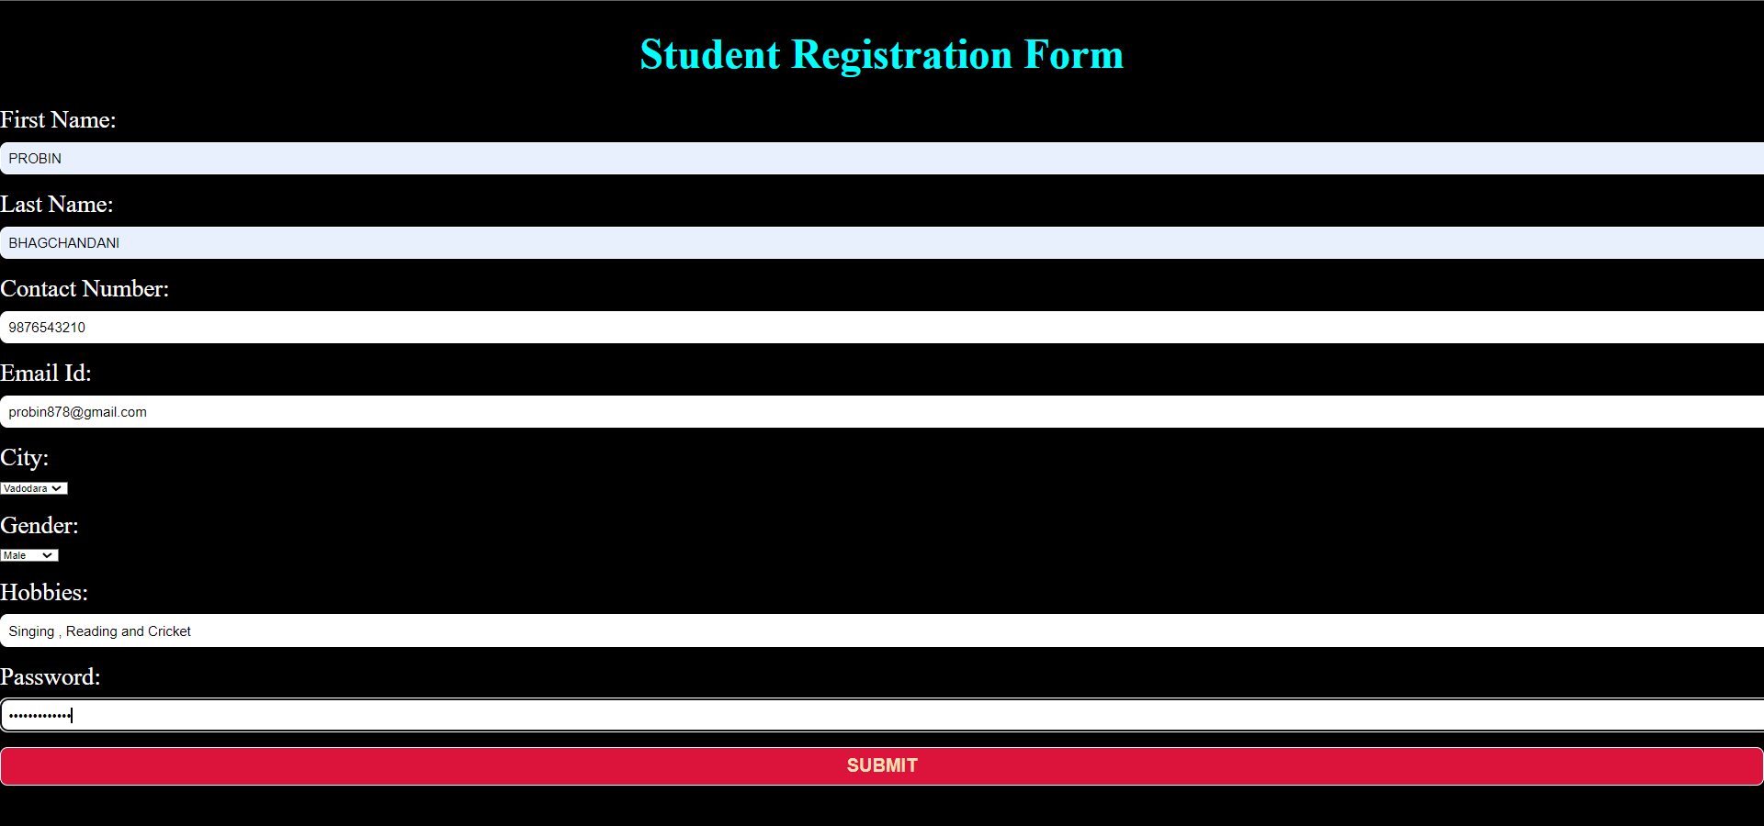

2)Login Form
Source Code:
<!DOCTYPE html>
<html>
<head>
<title>Login Page</title>
<style>
body {
background-color: #000;
color: white;
margin: 0;
}
h1 {
text-align: center;
color:cyan;

}
form {
width: 30%;
margin: 0 auto;
}
label {
font-size:x-large;
display: block;
margin-bottom: 10px;
}
input {
width: 100%;
padding: 10px;
border: 1px solid #ccc;
border-radius: 10px;
}
input[type="submit"] {
background-color:crimson;
width:105%;
font-size: large;
font-weight:bold;
color:wheat;
cursor: pointer;
}
p {
text-align: center;
}
a {
text-align: center;
font-size: large;
color:white;
text-decoration:none;
}
</style>
</head>
<body>
<br><br><br><br><br><h1>Login Page</h1>
<form action="/login" method="post">
<label for="username">Username:</label>
<input type="text" id="username" name="username"><br>
<br><label for="password">Password:</label>
<input type="password" id="password" name="password"><br><br>
<br><input type="submit" value="Login">
</form>
<p>Don't have an account? <a href="/signup">Sign up here</a>.</p>
</body>
</html>

Output:
